Task 1: Build the docker image and attach the volume to the running container

* By default if Container deleted, data of the Container also deleted
* To provide Data Persistency for the Containers Docker Volumes will be used
* Docker Volume is a Permanent Storage area

Step 1: Build the docker image using the dockerfile

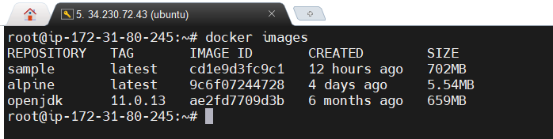

Step 2: Create the docker compose file with the image name, container and port

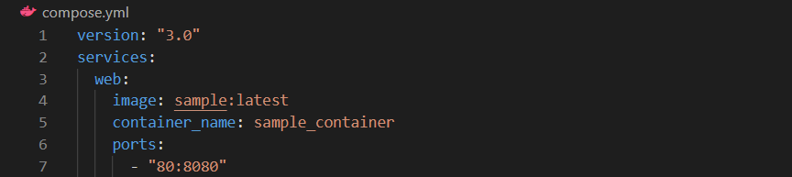

Step 3: Install docker compose

* sudo curl -L "https://github.com/docker/compose/releases/download/1.29.2/docker-compose-$(uname -s)-$(uname -m)" -o /usr/local/bin/docker-compose
* sudo chmod +x /usr/local/bin/docker-compose
* docker-compose –version

Step 4: Run the container using docker compose up

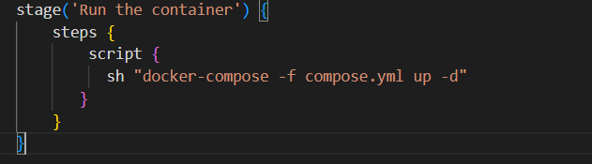

Step 5: To attach the volume:

1. We can mount the host machine directory to the container.
2. Create a new docker volume and attach to the container

Mounting the host machine directory to the running container:

* Create a directory in host machine
* mkdir -p /var/www/html
* vi index.html (some code)
* Now attach this volume in compose file

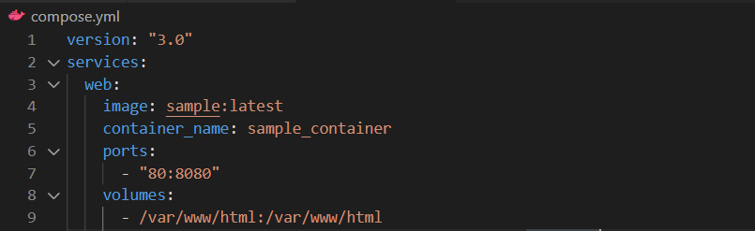

* Run the container using docker compose up
* Inside the container we can find the directory which is mounted as volume

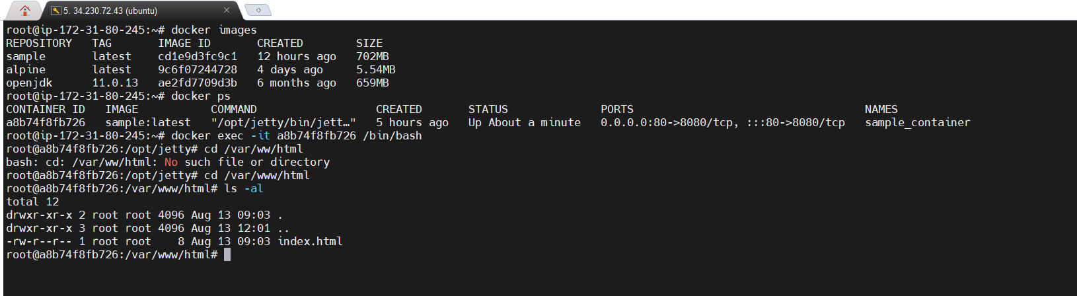

Creating a new volume and attach to the container

* Docker volumes are present inside - /var/lib/docker/volumes
* docker volume create poc-vol

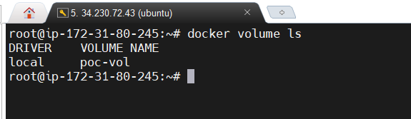

* Attach this volume in compose file

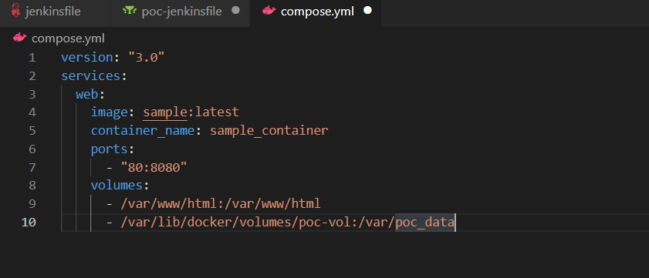

* Check the attached volume inside the /var

